CDE Download流程：

## 1，CDE下载到NT

Cli命令：admin software-mngt cdeprof download 135.242.96.160:MSR2JC43.001

1，CdeProfileMgntNt设置从cli获取到的下载ip和文件名

**CdeSnmp**.cc:

SetvoiceCDETarDldServerID

|-->return CdeConfig::getInstance().setCDEDownloadServer(*entry);

SetvoiceCDETarDldPath:

|-->return CdeConfig::getInstance().setCDEDownloadPackagePath(*entry);

| |-->CDEHandler::getInstance().checkCDEFileName(tmpDownloadPackagePath)

| | |-->CDEFileHndlr::decodeCDEFileName(cdeFileName,cdeFileCINSCypher,cdeFileProfileId, cdeFileISAMVReleaseNumber,cdeFileVersionNumber))

| | |-->checkCINSCypher(boardTypeId, cdeFileCINSCypher)

| | | |-->const CDEFileHndlr* cdeFileHandlerPtr=getCDEFileHandler(boardTypeId);

| | | |--> cdeFileHandlerPtr->isCINSCypherEqual(cdeFileCINSCypher);

| | | | |--> 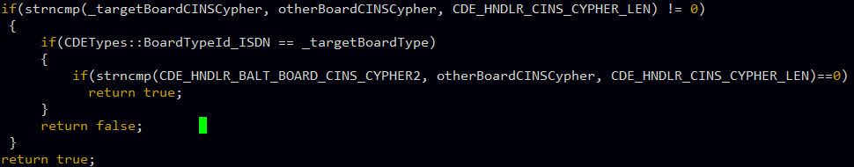

| |-->getCDETarFileNameFromPath(tmpDownloadPackagePath);

| |-->startDownload((void*)&cdeDownloadPackagePath)

| | |-->transferSession=fileTransferAccess(TFTP_GET,_downloadPackageName, _localDownloadPackageName,_downloadServerAddress,CDEConfig::endDownloadCallback);

| | | |-->CDEConfig::getInstance().endDownload(session_id,result,result_info);

| | | | |-->xt_start(utar_tid,T_PREEMPT,CDEConfig::getInstance().untarCDETask,NULL);

| | | | | |-->result=CDEConfig::getInstance().untarCDEPackage (CDE_HNDLR_LOCAL_UNTAR_DIR,CDEConfig::getInstance()._localDownloadPackageName);

| | | | | |-->errorCode=CDEHandler::getInstance().buildCDEPackageHndlr (CDE_HNDLR_LOCAL_UNTAR_DIR,newCDEPackageHandler);

| | | | | | |-->addCDEFile2CDEPackageHndlr(sourceDirectoryName, newCDEPackageHandler,(char const*)fileName)

| | | | | | | |-->

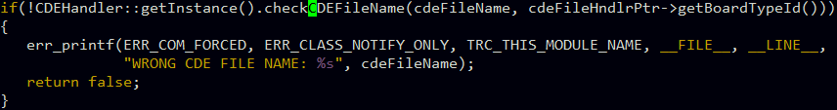;

## 2，active CDE

CDEConfig::activeCDE()

|-->newCDEPackageHandler=CDEHandler::getInstance().getCDEPackageHandler (CDE_NEW_PACKAGE)

|-->errorCode=CDEHandler::getInstance().activateCDEPackage(*newCDEPackageHandler)

| |-->FsDirectory::exist(CDE_HNDLR_LOCAL_ACTIVE_DIR);

| |--> 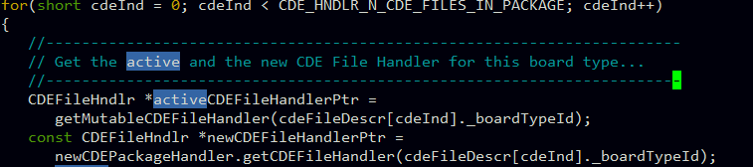

| |--> if(!activeCDEFileHandlerPtr->replaceCDEFile(*newCDEFileHandlerPtr))

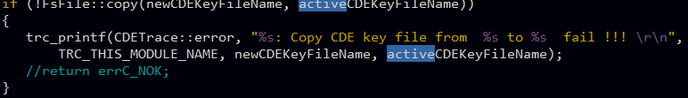

| |--> return transferCDEProf2LSM(false); wile循环所有的pot

| | |--> CdeTransWrapper::getCdeTransWrapper()->activateCdeTrans(slotId,boardType, activeCDEFileName,snmpOrIocm);

| | | | |--> if (true != CDEHandler::getInstance().cdePackageHmac(CDETypes :: CDE_ACTIVE_PACKAGE))

| | | | | |-->

| | | | |-->retVal=initCdeTrans(boardType,slotId,isIocmTask);

| | | | |-->retVal=compCde(boardType,slotId,isIocmTask);

| | | | | |-->status=cdeLsmToNtIfc.getCdeVersion(iocm_version);

| | | | | |-->status= cdeLsmToNtIfc.getCdeProfileId(iocm_info);

| | | | | |-->status= cdeLsmToNtIfc.getCdeRelease(iocm_release);

| | | | |-->retVal=preCdeTrans(boardType,cdeFileName);

| | | | |-->status= cdeLsmToNtIfc.transferCde(iocm_type,True);

| | | | |-->|--> retCode = iocmGetCdePiece( iocm_cdetype, iocm_index, iocm_info, pieceLength);

| | | | |-->|-->retCode = writeCdePiece(cde_type, local_index, iocm_info, pieceLength);

| | | | |-->|-->retCode = iocmGetCdeChecksum( iocm_cdetype, checksum);

| | | | |-->|-->retCode = checkCdeFile(cde_type, totalSize, checksum);

| | | | |-->|--> retCode = iocmReportCdeValidity(iocm_index, True);

| | | | |-->|--> retCode = iocmGetCdeVersion( iocm_cdetype, iocm_index, iocm_version);

| | | | |-->|-->retCode = writeCdeVersion(cde_type,iocm_version);

| | | | |-->|-->retCode = iocmGetCdeProfileId(iocm_cdetype, iocm_index, iocm_profileid);

| | | | |-->|-->retCode = writeCdeProfileId(cde_type, iocm_profileid);

| | | | |-->|-->retCode = iocmGetCdeRelease( iocm_cdetype, iocm_index, iocm_release);

| | | | |-->|-->retCode = writeCdeRelease(cde_type,iocm_release);

## 3，LT上CDE文件读取 ——不负责

1，AccessNeSipw初始化initCde

pZips->initCde();

5，sipwrapper初始化，读取cde

AccessNeZIPS::initCde();

|-->readCdeFile();

| |--> retCode = SipwParseCdeData();

| | |--> SipwInitCdeParam();

| | |-->rc = pInstance->getKeyNameItem(token_table[i].initialToken,&value[tokenLen + 1], pNode);

## 4，CDE从NT下载到LT

1，Pltf_app_init.app: LT启动时初始化CdeProfileMgntLsm：

CdeProfileMgntLsmInterface::getCdeProfileMgntLsmInterface()->initCdeProfileMgntLsm(true);

|-->CdeCtrlTask::initCdeCtrlTask(isActive);

| |-->xt_start(os_taskId, T_PREEMPT | T_NOASR | T_TSLICE, void (*)(void))CdeCtrlTask::startCdeCtrlTask, args);

| |-->CdeTrans::Cde_NtToLsm_ifc cdeNtToLsmIfc

……

| |-->result = reportPlugin();

| | |-->status = cdeNtToLsmIfc.reportLsmPlugin(iocm_index);

2，cdeNtToLsmIfc.reportLsmPlugin通过IOCM调用到CdeTransSrv.cc的reportLsmPlugin方法

Void CdeTransSrv::reportLsmPlugin()

|-->retvalue=CDEHandler::getInstance().cdeTransfer(local_type,slotId,true);

| |-->CdeTransWrapper::getCdeTransWrapper())->activateCdeTrans (slotId,cde_type, activeCDEFileName, snmpOrIocm);

| | |-->retVal=initCdeTrans(boardType,slotId,isIocmTask);

| | |-->retVal=compCde(boardType,slotId,isIocmTask);

| | | |-->status=cdeLsmToNtIfc.getCdeVersion(iocm_version);

| | | |-->status= cdeLsmToNtIfc.getCdeProfileId(iocm_info);

| | | |-->status= cdeLsmToNtIfc.getCdeRelease(iocm_release);

| | |-->retVal=preCdeTrans(boardType,cdeFileName);

| | |-->status= cdeLsmToNtIfc.transferCde(iocm_type,True);

3，LT在transferCde方法中接收cde文件片段并处理

void CdeCtrlSrv::transferCde

|--> retCode = iocmGetCdePiece( iocm_cdetype, iocm_index, iocm_info, pieceLength);

|-->retCode = writeCdePiece(cde_type, local_index, iocm_info, pieceLength);

|-->retCode = iocmGetCdeChecksum( iocm_cdetype, checksum);

|-->retCode = checkCdeFile(cde_type, totalSize, checksum);

|--> retCode = iocmReportCdeValidity(iocm_index, True);

|-->retCode = writeCdeVersion(cde_type,iocm_version);

|-->retCode = writeCdeProfileId(cde_type, iocm_profileid);

|-->retCode = writeCdeRelease(cde_type,iocm_release);

4，SipWrapper初始化SipWCdeHandler时获取写入到flash disk中的cde数据，进行有效性检测

SipwCdeHandler::SipwCdeHandler ()

|-->(CdeProfileMgntLsmInterface::getCdeProfileMgntLsmInterface())->getCdeData(CDEFileMem);